Mesh Project
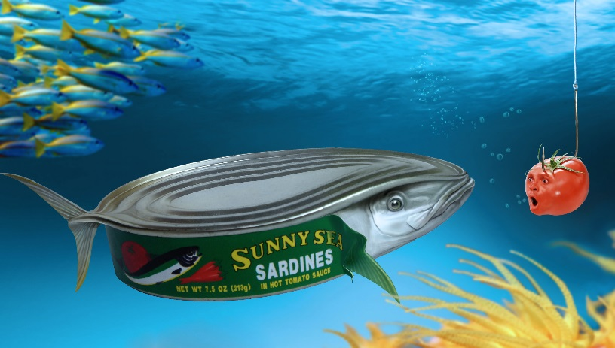
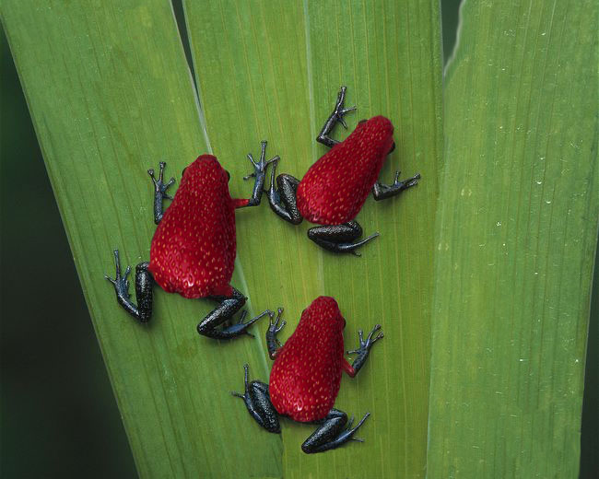
Blending an animate object with an inanimate object

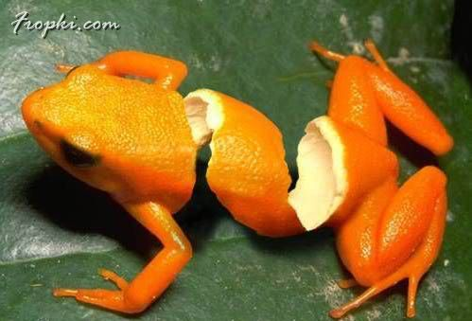
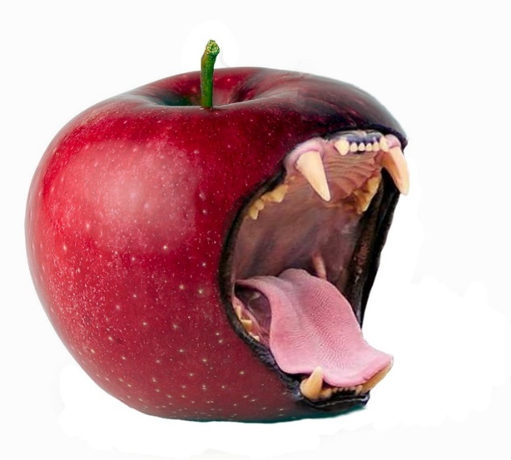

https://www.fropky.com/most-amazing-photoshopped-animals-vt42685-22.html
For this project you will need to bring an inanimate object to life! Combine an animate object (a living creature) with an inanimate object (not moving) to create a seamless, unified, composition that includes a background.
LAYER MASKS are going to be your best friend for this assignment.
ADJUSTMENT LAYERS will be very necessary in order for the lighting, values and colors to match. Levels, Hue/Sat, Photo filter etc.
The PAINTING TOOLS will also be needed in order to seamlessly blend your images together.
Basically the image must look totally realistic as though the photo was actually taken that way.

