The Human Condition
The human condition encompasses the unique features of being human. It can be described as the irreducible part of humanity that is inherent and innate to human beings and not dependent on factors such as gender, race or class. It includes concerns such as the meaning of life, the search for gratification, the sense of curiosity, the inevitability of isolation, or awareness regarding the inescapability of death.
- Create a black&white drawing on a collaged mixed media background based on your interpretation of the “human condition.” The drawing may be done in charcoal, ink or colored pencil.
- This is a very open topic and there is no correct or incorrect way to represent it. BUT it is about the human condition so using a human figure or a part of a figure is pretty much unavoidable.
- You must use a reference photo(s) for the human. Using your own photos is always a good choice because you can get the exact angle and pose you want.
- The mixed media background can be a collage of book pages, newspaper, decorative papers, maps, sheet music, phonebook pages, cardboard etc.
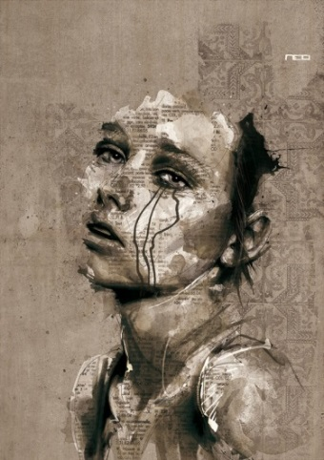
- When your drawing is complete use some form of color for variety and emphasis. Think of how you might use alternative materials for this step instead of just paint, colored pencils etc. You may choose to use a single red thread, or stamp a pattern. Be creative!
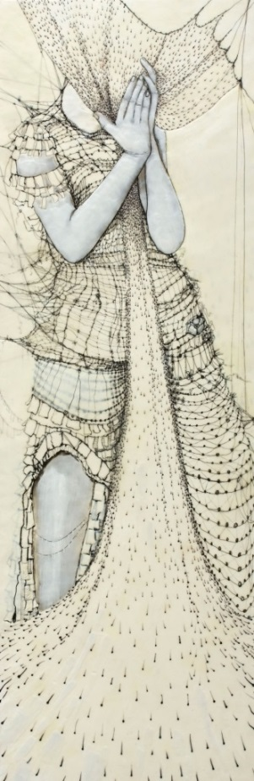
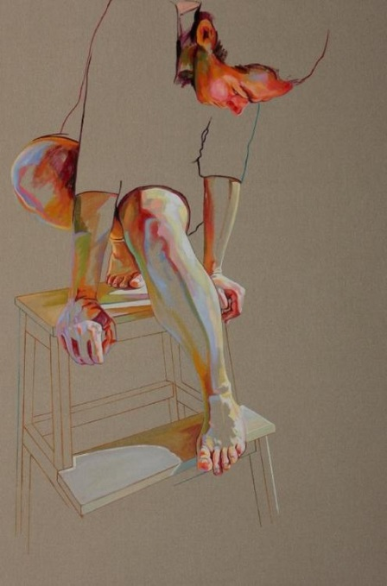
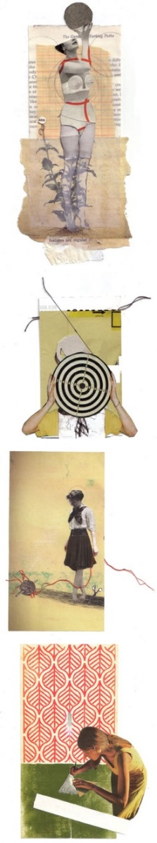
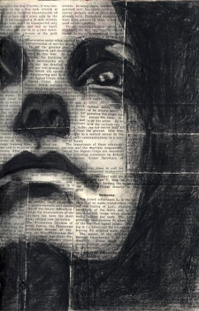
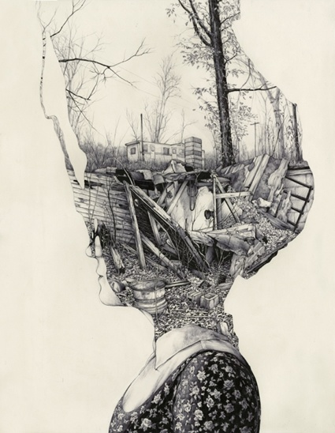

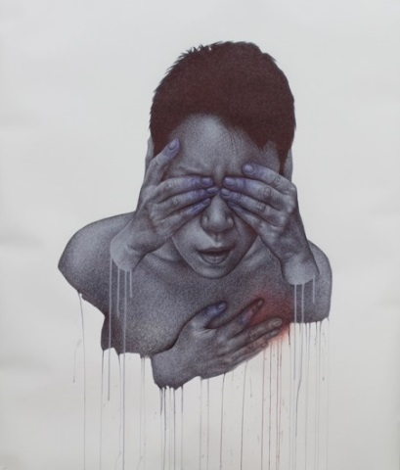

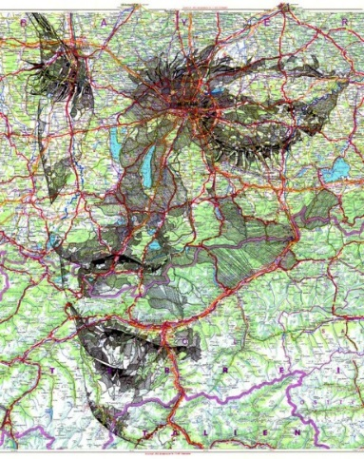

AVOID CLICHÈS!!!
Choosing LOVE as a human condition can be very difficult because our culture is saturated with images representing love. It will be incredibly difficult to avoid stereotyped imagery with this theme. If you do want to use love, narrow down the scope of this emotion by picking another emotion associated with it. The pain of a breakup, jealousy, infatuation, loving someone who doesn’t feel the same way about you etc. You can do this exercise with any range of human conditions in order to avoid the cliché.
What can you add to these lists?
Images to avoid  Hearts, peace signs, close ups of an eye, eye with the earth in it, eye with a single tear drop, anime characters, pot leaves, silhouetted sunset, people without hands or feet, anything drawn without a reference photo… | Human Conditions  Curiosity, pride, inferiority, melancholy, longing, achievement, feeling at peace, existential crisis…take any basic human emotion and make it more specific. Take joy, for example. Is it the joy of opening presents on Christmas morning or the joy of holding a newborn baby? Relate to moments from your own life.

- Collaged background - Collage book pages, newspaper, decorative papers, maps, sheet music, junk mail, phonebook pages, cardboard etc. Keep the arrangement organized and use a maximum of 12 pieces of paper. They may be all different kinds of paper or all the same. Use matte medium to glue down.
- Drawing- Draw your figure so it fills at least ¾ of the picture plane. It can go off the edges. Use black media only and use a reference photo. You can use contour line or make it fully shaded. The term human “figure” can be applied loosely. You do not have to draw the face or include the entire body. Get compositions approved first.
- Color- Add a small amount of color to provide interest and emphasis. This may be a blush of faded color in the background or creatively placed threads dangling off the edges. Be creative with this step BUT make sure the color does not distract too much from the drawn figure which should remain you main focal point.

